Realistic High Resolution Globes

Contents
- 1 high resolution Photoshop file ( 6000 x 4700 px ).
- 8 jpeg files ( all angles saved from the Photoshop file ).
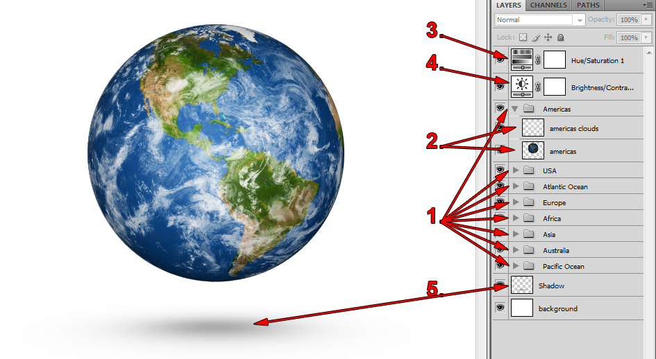
Using the Photoshop File
- Layers are separated into groups by globe angles ( 8 in total ).
- Each group has two layers:
- Clouds (rotate this to move the clouds)
- Globe
- Saturation control ( turn this layer off to get realistic colors )
- Brightness/Contrast control
- Shadow under the globes

