## [tham khảo] Brand book (Manual book) của cty DSM

Nhân đang học môn CIP và được thầy cho xem Manual Book, mình up 1book của cty DSM để các bạn tham khảo thêm.  
  
[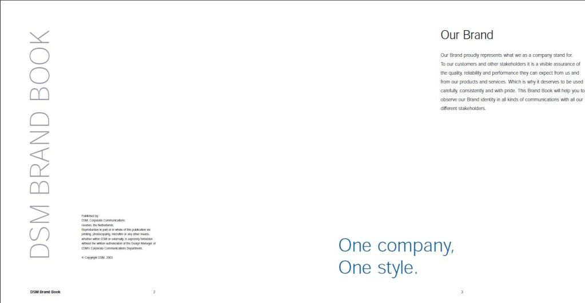](http://i989.photobucket.com/albums/af15/darudedpi/dpi/brand1.jpg)  
  
[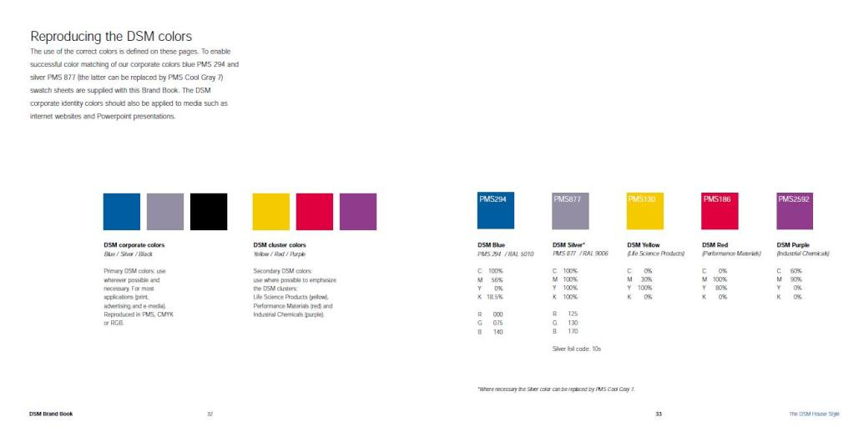](http://i989.photobucket.com/albums/af15/darudedpi/dpi/brand2.jpg)  
  
File pdf:

Code:

<http://www.mediafire.com/?knyg3mig43t>

Và links về Branding & Corporate Indentity một số công ty:

[ABB](http://www.abb.com/visualidentity)  
[Accelrys](http://www.accelrys.com/about/corp_guidelines)  
[Air Products](http://www.airproducts.com/identity)  
[Akzo Nobel](http://www.akzonobel.com/company/identity)  
[American Heart Association](http://www.americanheart.org/branding)  
[BAE Systems](http://www.baesystems.com/identityguidelines)  
[Boehringer Ingelheim](http://cd.boehringer-ingelheim.com/)  
[Cable & Wireless](http://www.cw.com/brand)  
[Capgemini](http://www.capgemini.com/visualidentity)  
[Cargill](http://www.cargillbrandidentity.com/)  
[CEZ](http://www.cez-brand.cz/)  
[Cornell University](http://www.cornell.edu/identity)  
[Cunard](http://www.cunardguidelines.com/)  
[DaimlerChrysler](http://www.designnavigator.daimlerchrysler.com/)  
[DFDS Transport](http://corpid.dfdstransport.com/)  
[Diebold](http://www.diebold.com/idmanual)  
[DSM](http://identity.dsm.com/)  
[Heineken](http://www.heinekenidentity.com/)  
[HEWI](http://www.corporatedesign.hewi.com/)  
[Home Office](http://www.homeoffice.gov.uk/logoguide)  
[Hong Kong](http://www.brandhk.gov.hk/)  
[Knight Frank](http://www.knightfrank.com/kf/aboutknightfrank/identityguidelines)  
[Lilly](http://branding.lilly.com/)  
[Lloyd’s](http://www.lloyds.com/brand)  
[Macmillan](http://be.macmillan.org.uk/)  
[Mosaic](http://www.mosaicco.com/public)  
[National Health Service](http://www.nhsidentity.nhs.uk/)  
[Nortel](http://www.nortel.com/corporate/corpid)  
[Northern Ireland Departments](http://www.northernireland.gov.uk/identity)  
[Novo](http://www.novo.dk/cvi)  
[Novozymes](http://www.novozymes.com/cvi)  
[Océ](http://identity.oce.com/)  
[PPG Industries](http://www.ppg.com/globalidentity/hp_01.shtml)  
[Reuters](http://about.reuters.com/corpid)  
[San Francisco International Airport](http://www.flysfo.com/brand)  
[Siemens](http://brandville.siemens.com/)  
[Smiths](http://www.smiths-group.com/)  
[Smithsonian Institution](http://www.si.edu/silogo)  
[Sure Start](http://www.surestart.gov.uk/brand)  
[Technische Universiteit Delft](http://www.housestyle.tudelft.nl/)  
[The University of Nottingham](http://www.nottingham.ac.uk/corporate-id)  
[The University of Warwick](http://www.warwick.ac.uk/services/publicity/id)  
[Thomson](http://brand.thomson.com/)  
[TNT](http://group.tnt.com/brandweb)  
[Transport for London](http://www.tfl.gov.uk/corporatedesign)  
[Unilever](http://thebrandcentreforsuppliers.unilever.com/)  
[University College Dublin](http://www.ucd.ie/visualidentity)  
[Vanderbilt University](http://www.vanderbilt.edu/publicaffairs/cs/graphicstandards)  
[YWCA](http://www.ywcabrand.org/)

Hy vọng sẽ có ích cho các bạn http://dohoadpi.info/forum/images/smilies/yahoo/1.gif