Quảng cáo trên cây cột
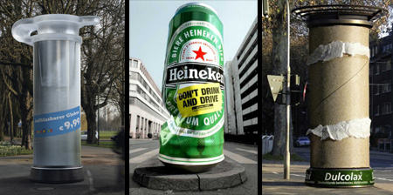
Creative uses of columns, poles and pillars in advertising campaigns by various companies.

Anti Smoking Column Advertisement
Regular advertising columns in Germany were turned into giant stubbed out cigarettes to encourage smokers to quit smoking.
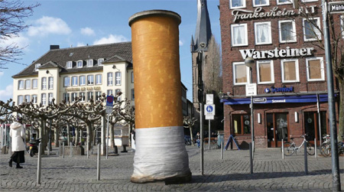

Global Coalition for Peace Column Ad
Creative posters were designed to wrap around poles, campaigning for an end to the war in Iraq, pointing to Global Coalition for Peace website. [link]
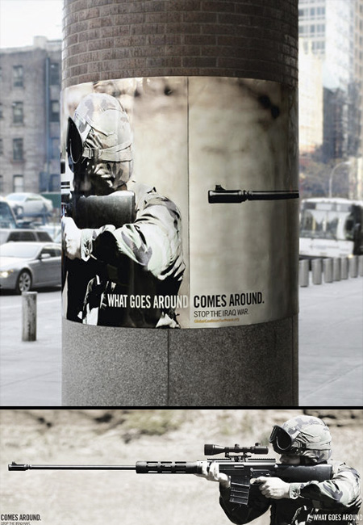

McDonald’s Column Advertisement
This is a standard Danish advertising column. The top of the advertising column has not been modified. Nothing was added but the poster. “Shelter served at McDonald’s”. [link]
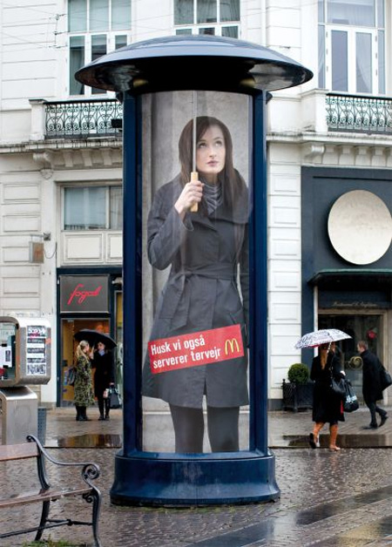

Greenpeace Column Advertisement
Advertising pillars were turned into giant medical syringes. “There’s no better medicine for the environment than your contribution”. [link]
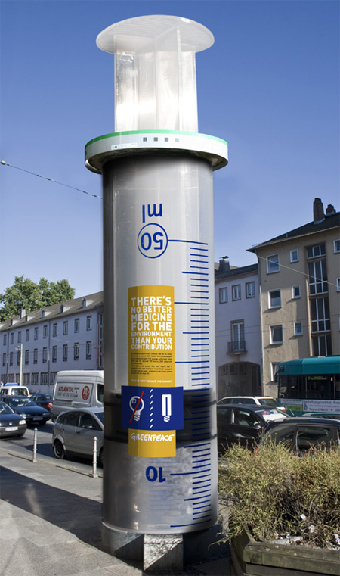

Ice Age Column Advertisement
Creative ad column promotes Ice Age 2: The Meltdown animated movie.
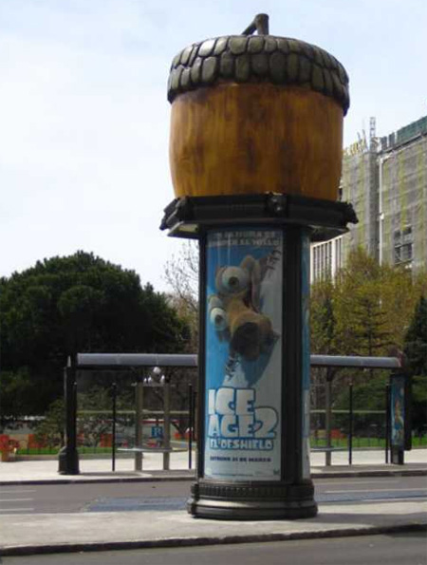

Sci-Fi Channel Column Advertisement
“UFO invasion” advertising column promotes Sci-Fi TV channel.
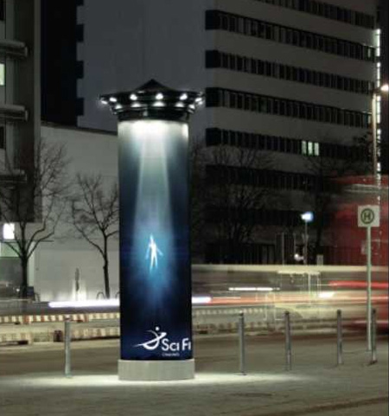

Fiat Pillar Advertisement
Stickers were attached to damaged pillars at parking lots. “Save the pillars. Fiat Stilo with parking sensor”. [link]
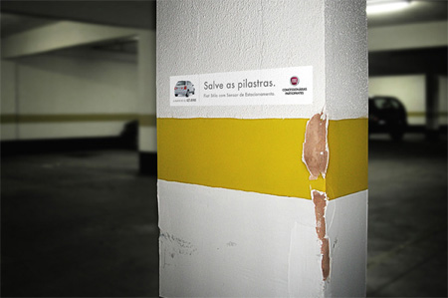

Toys “R” Us Column Advertisement
Clever advertising column promotes the Toys “R” Us inflatable beach toy collection. [link]
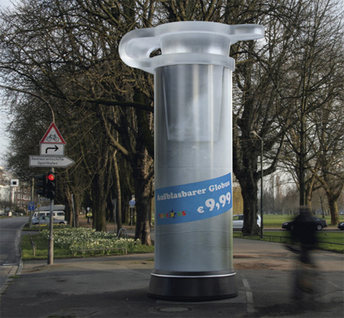

Dulcolax Column Advertisement
Ordinary advertising columns were turned into giant toilet paper rolls in Dusseldorf, Germany. [link]
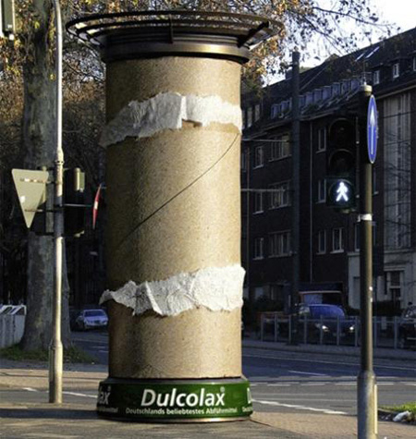

Heineken Column Advertisement
Clever Heineken beer column advertisement from Switzerland reminds us not to drink and drive.
