Quảng cáo trên cầu thang
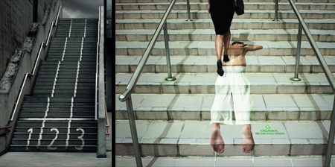
See what happens when companies use stairs to advertise their products.

IKEA Stairs Advertisement
Store’s main staircase was presented as a chest of drawers, with everything inside neatly organized. [link]
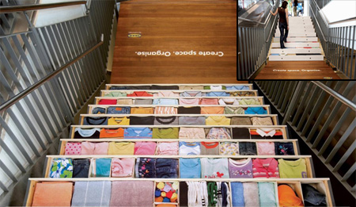

Coca-Cola Stairs Advertisement
Coke Light was advertised to people using the escalator and regular Cola to those who chose the stairs. [link]
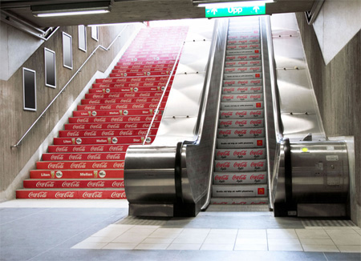

Jeep Stairs Advertisement
Clever parking space on the stairs reserved only for Jeep cars. [link]
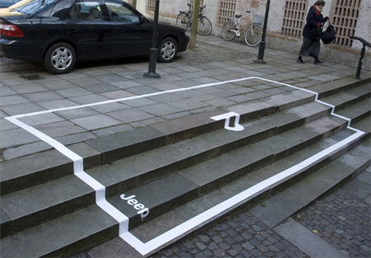

Literacy Association Stairs Advertisement
Creative campaign created to generate book donations for the Greenville Literacy Association. [link]
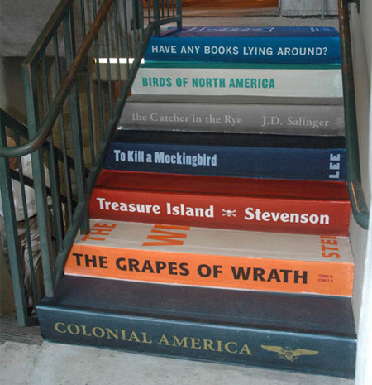

Shopping Mall Stairs Advertisement
The stairs of the main shopping mall entrance were transformed into a track that extends to the central entrance. [link]
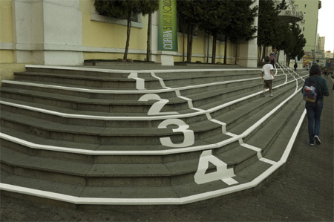

Nationwide Stairs Advertisement
Nationwide Auto Insurance: Life comes at you fast. [link]
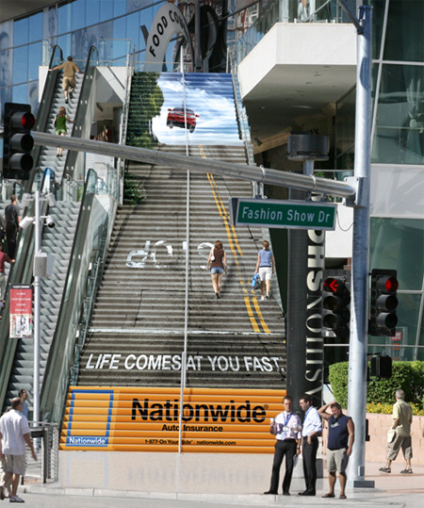

Parkinson’s Disease Stairs Advertisement
The world looks different when you suffer from Parkinson’s. [link]
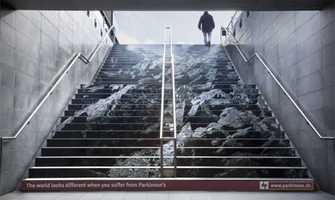

ADD Stairs Advertisement
You cannot imagine what it’s like to compete everyday of your life. Sponsor and support handicapped athletes. [link]
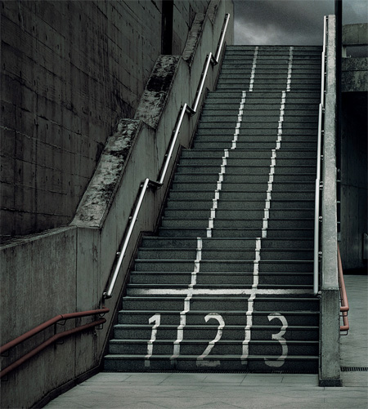

Massage Stairs Advertisement
Clever stickers were strategically placed at selected stairways around the city to promote Ogawa’s first class massage. [link]
