Quảng cáo câu khách
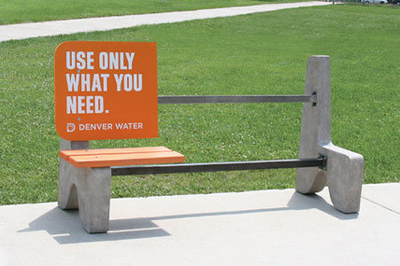
Check out these creative and unique advertisements from around the world:

3M Security Glass Advertisement
3M was so sure their Security Glass was unbreakable, they put a large stack of cash behind it and shoved it in a bus stop. [gizmodo]
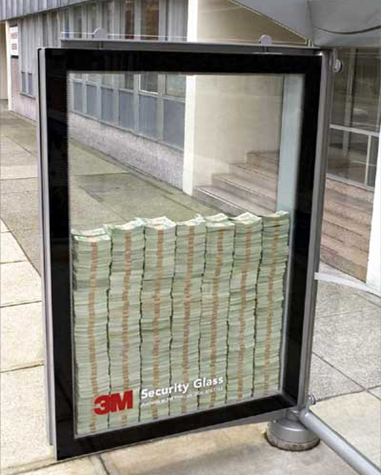

Radiant Gym “Running” Advertisement
Obesity finds it hardest to catch up with those who are running. [lemonflip]
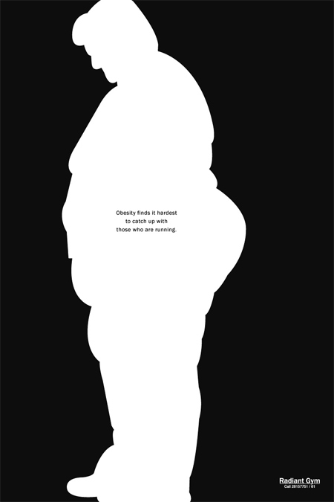

YKM Bag Advertisement
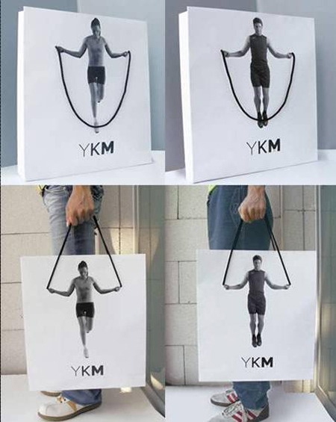

Where’s your child?
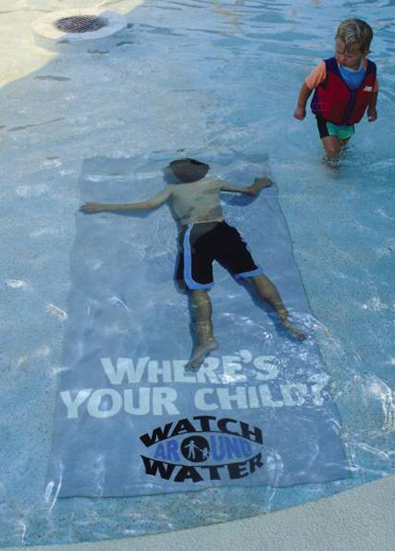

Yodobashi Camera Store Bus Advertisement
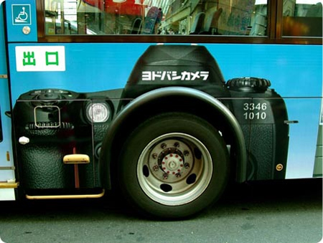

Premiere “Spiderman” Advertisement
Your TV program takes a break when you do.
Personal digital TV with delayed viewing. [adsoftheworld]
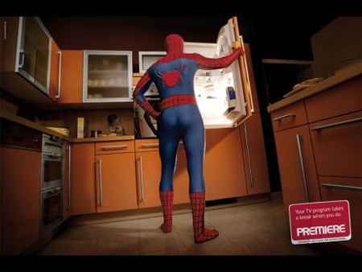

Creative Adidas Advertisement
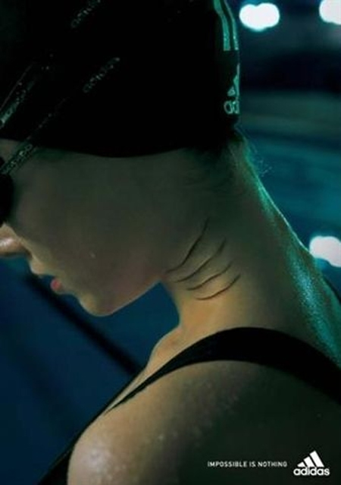

Funeral Services Advertisement
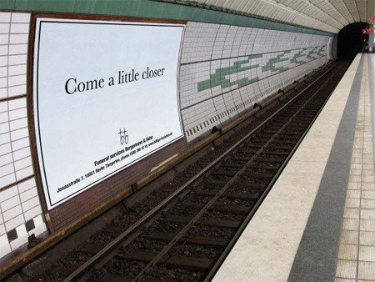

Stop’n Grow Bag Advertisement
German product that stops nail biting. [flickr]
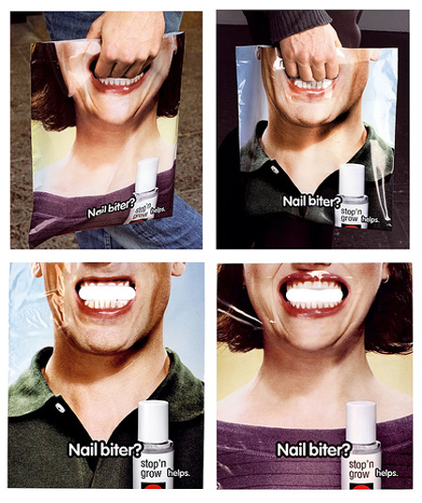

Denver Water Advertisement
Use Only What You Need.

Sharpie Permanent Markers Advertisement
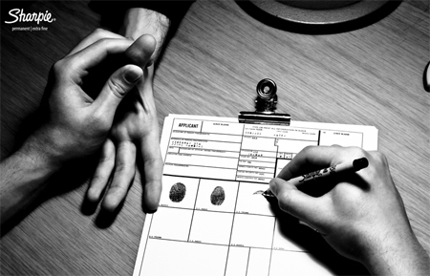

Samsung “Express Yourself” Advertisement
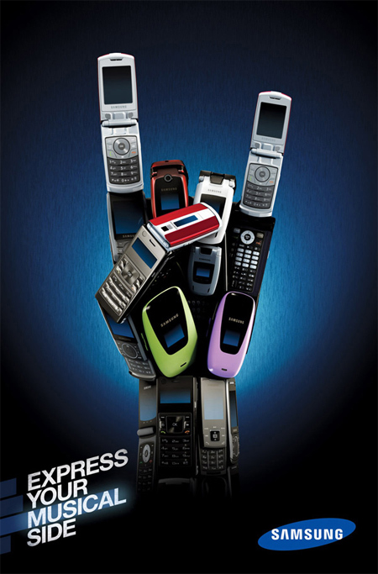

“Reserved for Drunk Drivers” Advertisement
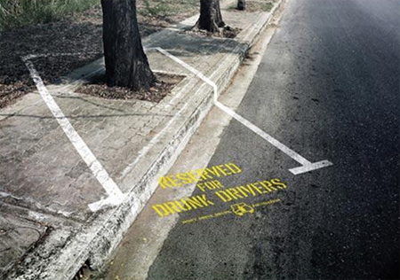

Dettol Instant Hand Sanitizer Advertisement
