Quảng cáo đóng một vai trò đặc biệt quan trọng trong kinh doanh và Poster quảng cáo là một trong những cách để người ta truyền tải một thông điệp nào đó đến người xem. Hôm nay, chúng tôi xin được chia sẻ với các bạn rất rất nhiều Poster “đẹp dã man” mà chúng tôi sưu tập được.
Bạn yên tâm nhé vì chắc chắn rằng bạn sẽ không phải thất vọng vì đã tốn thời gian để xem bài viết này đâu! Nếu thấy thích thì làm ơn bỏ thêm chút xíu thời gian để nhấn vào nút Thích và chia sẻ đến bạn bè của bạn nhé! Đến với Đẹp Lạ nghĩa là “Hãy nhìn – cảm nhận” và “Không ngừng sẻ chia”.

Novartis “Reflections” Campaign – by Tom Hussey
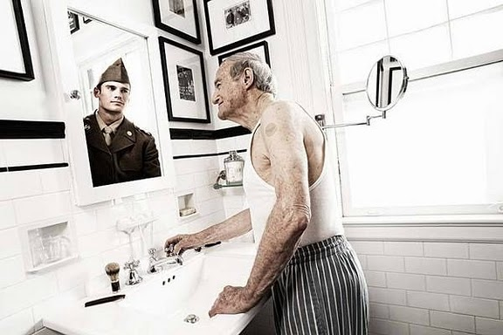

global warming PSA – time – by pepey
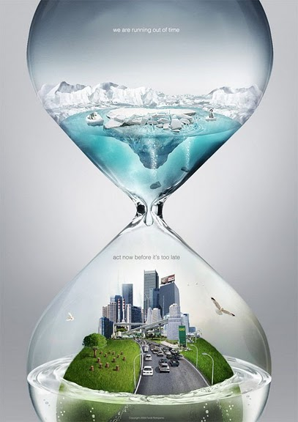

Piranha – by meldy
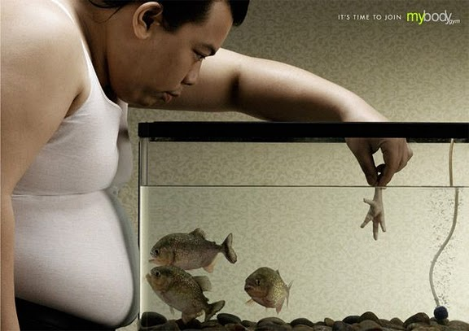

Tiger Beer : Energy – by archanN
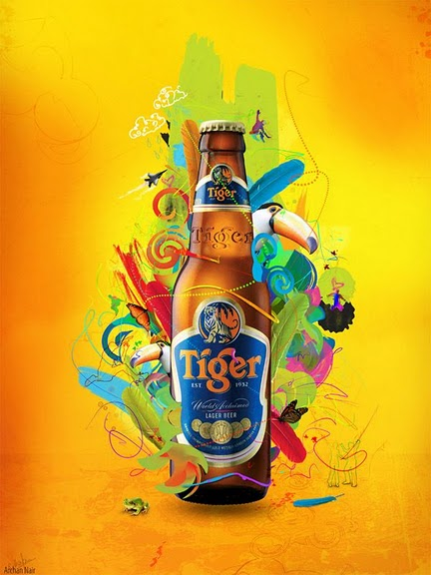

BEAUX ARTS Magazine – by Waldo LEE


Discovery Channel – Life – by Peter Jaworowski
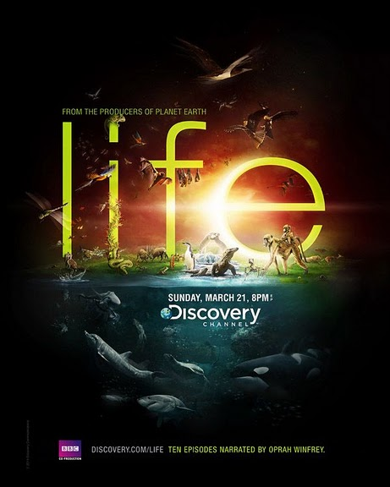

2009 Performance – by Job Hall
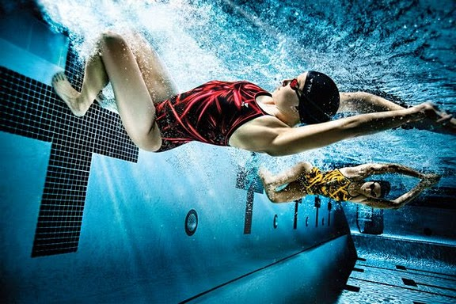

Nike – by Guy Seese
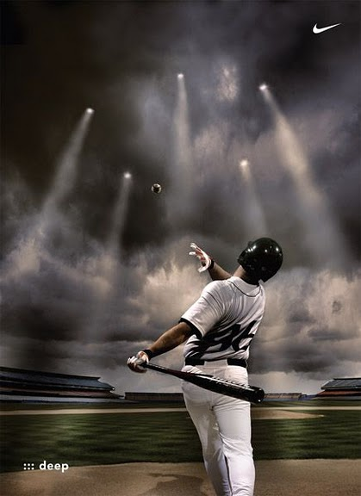

Road Safety for Kids – by Fil Dunsky
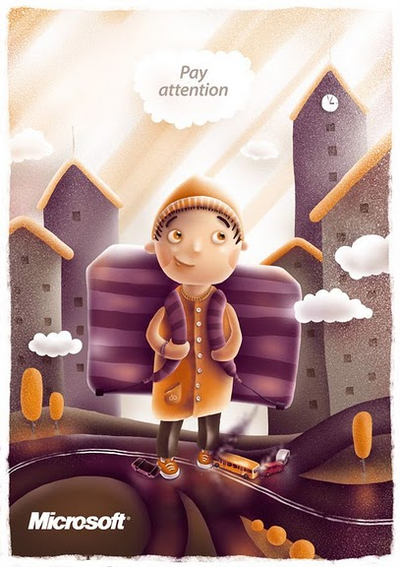

louboutin’s stories – by KHUONG NGUYEN
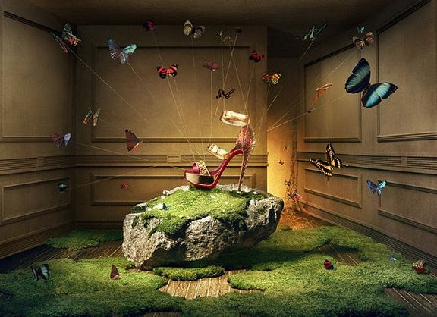

The Joy Ballad – by Archan Nair & Parris Whittingham


Drink and Drive – time – by pepey
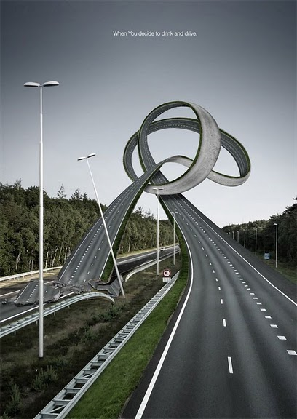

Print. CEPSA – by David Titos
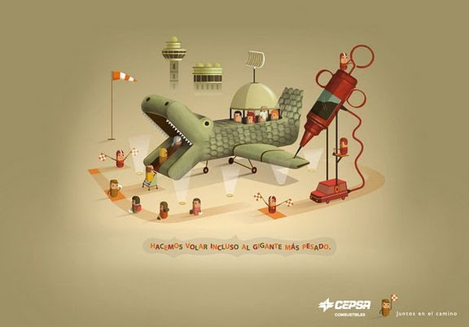

Bacardi – Shoot & Fly – by Peter Jaworowski
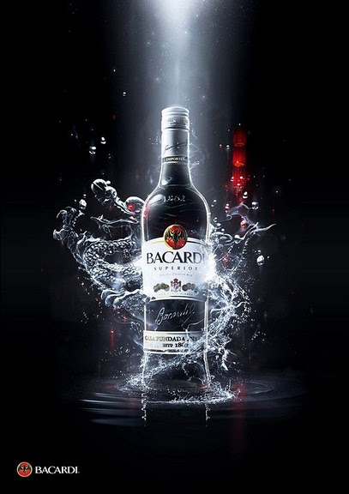

Harley-Davidson – by Brock Davis
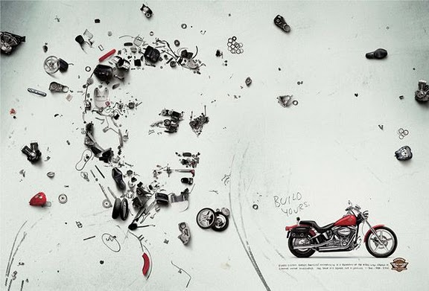

your singapore – by nicolas lesaffre


THE PURSUIT OF HAPPINESS – by cms
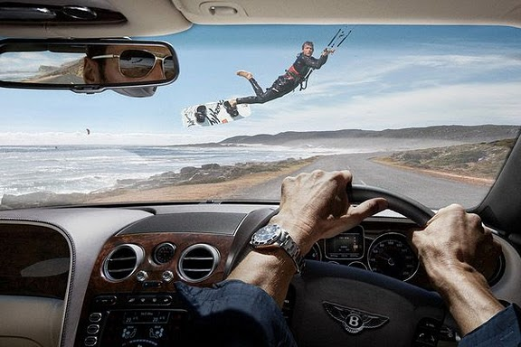

SCREAM – by cms
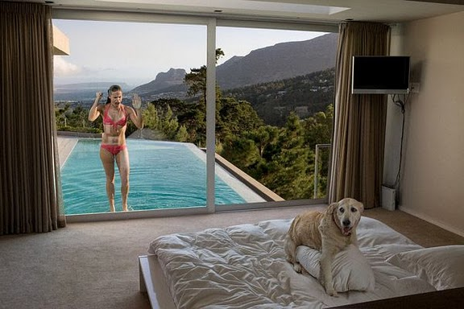

A Day at the Zoo – by t-wei
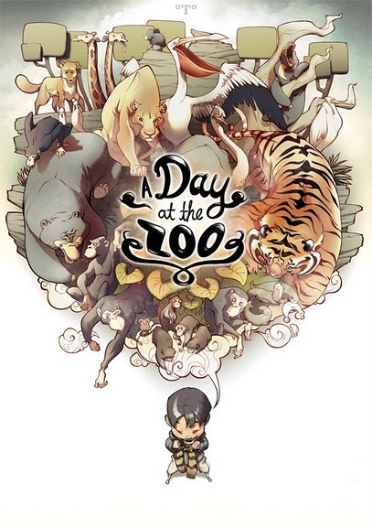

sustentavel – by felipeart


Fight Global Warming – by BlakliteGraphics
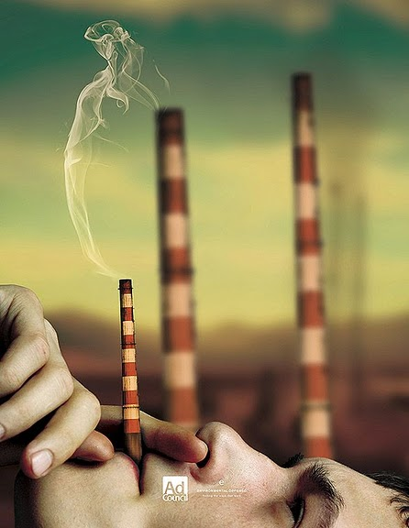

Abortion – by EN70


Martini Asti Elements – Earth – by he1z
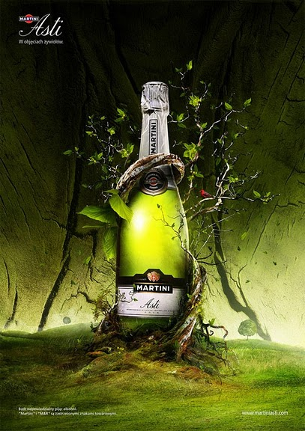

Fight Glasses – by BeingNice
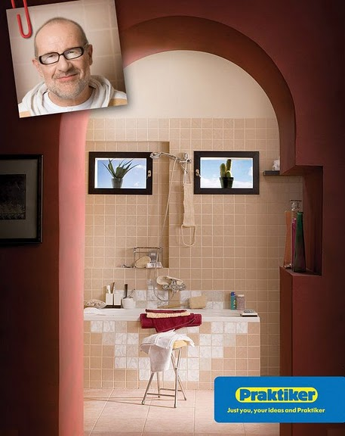

MINI COOPER “Rollercoaster” – by akocpinoy
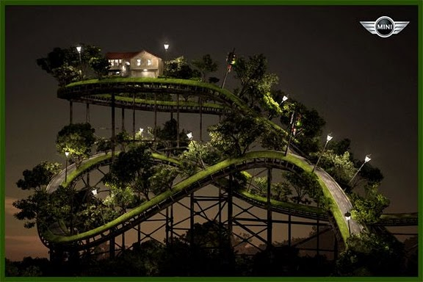

Save Nature – by CALLit-ringo
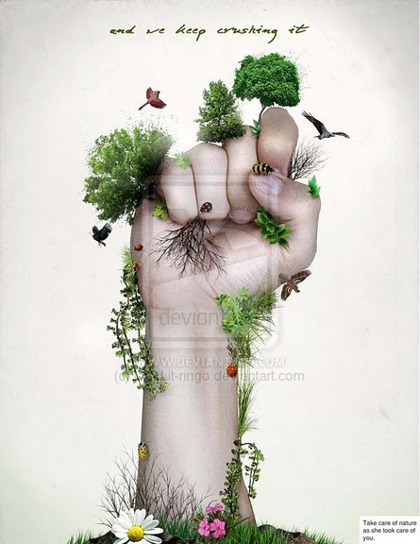

Hugo2- One Fragrance, One Tree – by pepey
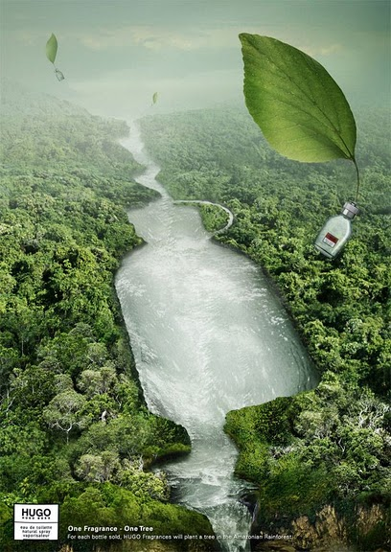

Deliciously Dark Thoughts – by NatalieShau


Coca Cola Happiness Factory
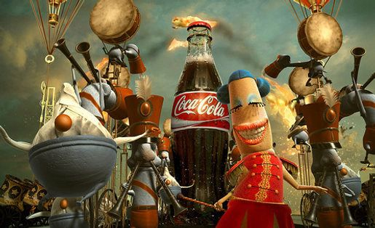

save water 2 – by serso
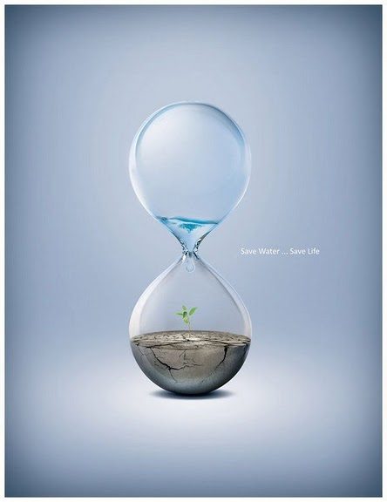

liquid color – by CHIN2OFF
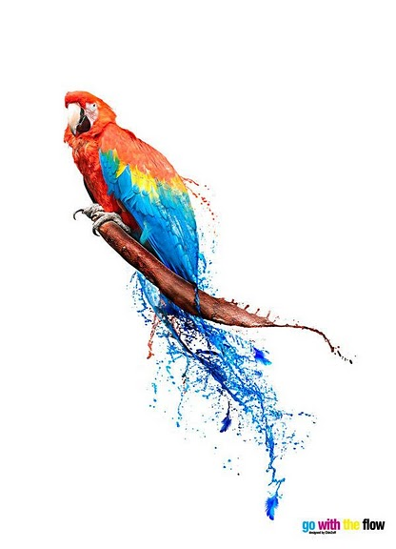

Gatorade always wins
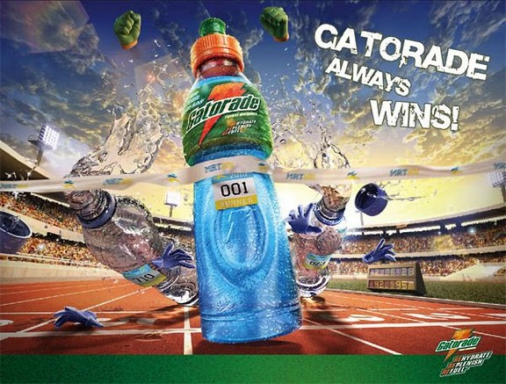

Open House – by Demen1


C2 advocacy ad. – by bluzero8
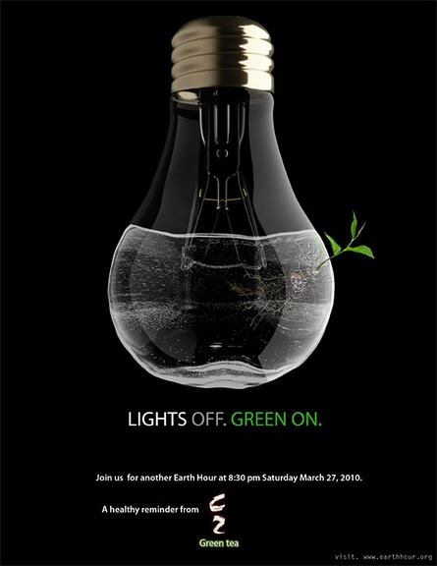

RPM HDD Clock – by Uribaani
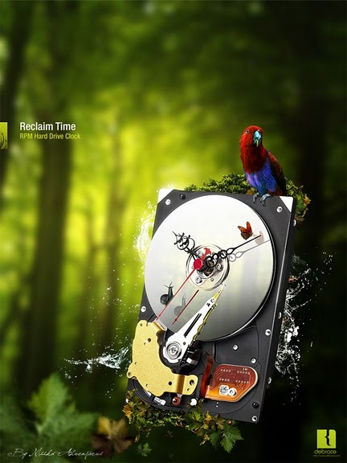

Emerald and the Dead Fishermen – by chibighibli
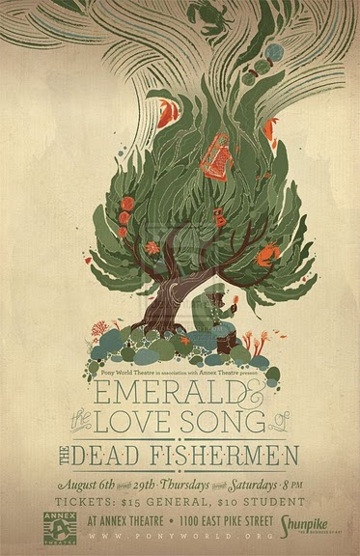

KDU x Adidas – by Biomachina


Evolution – by Ferdi Rizkiyanto
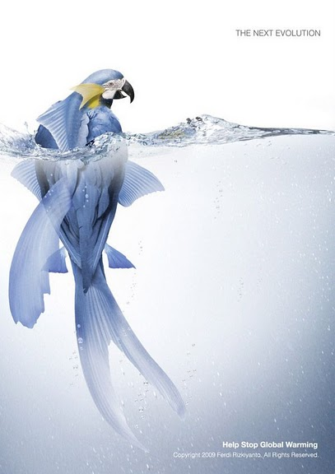

Nuclear Evolution – by h4nd
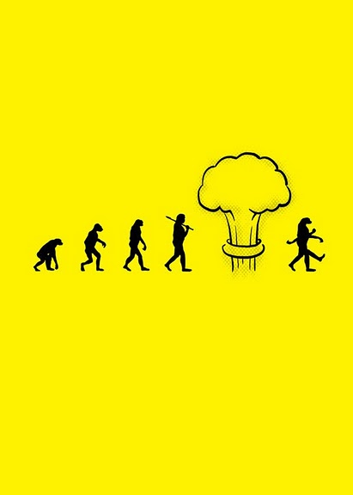

Fear of being Cute – by ~fERs
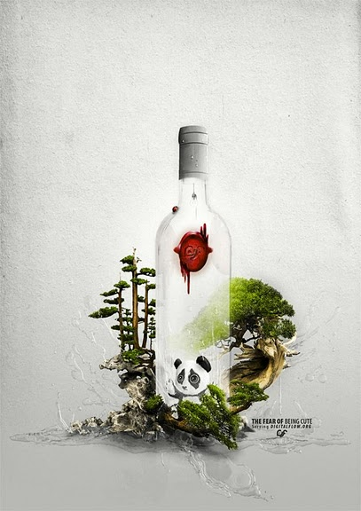

Coffee Dream – by Zim-dez
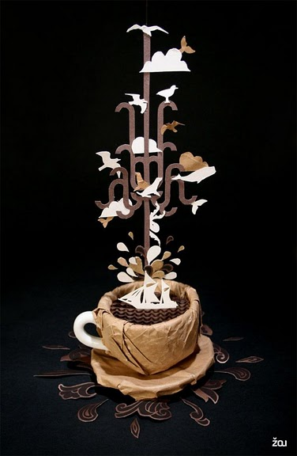

Positive Hype – by he1z


Microsoft Virtualization: Universe
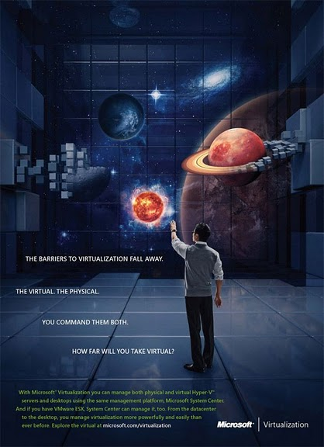

As I See It – by Mark Holthusen
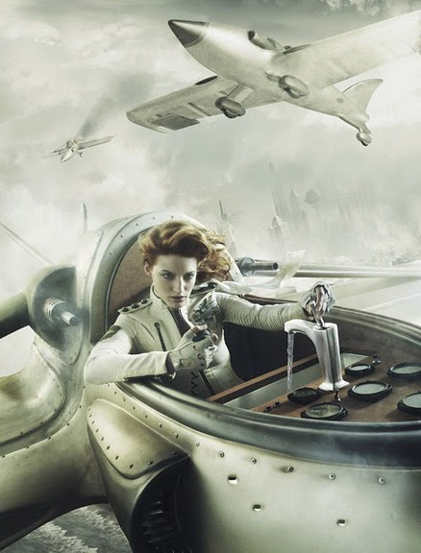

An adventure through time – by ontwerpje
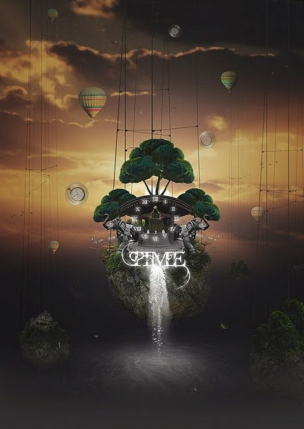

Playstation 3 – HD – by he1z


Atlas holding our world – by KarimDesign
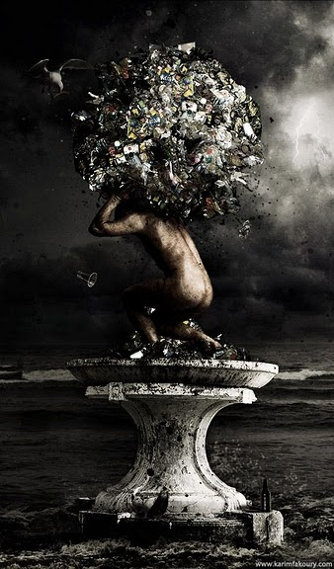

creativity ? – by wesso85
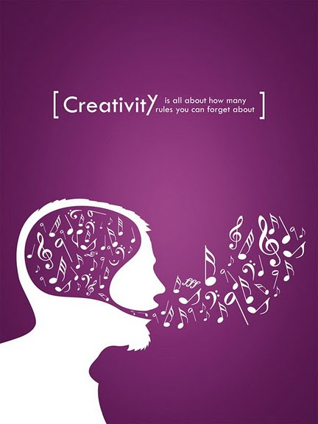

street shop – by menduza
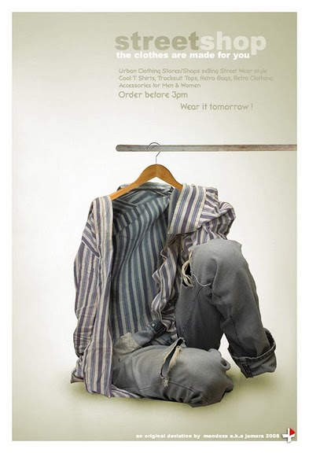

iPod-Play Your Music – by svpermchine
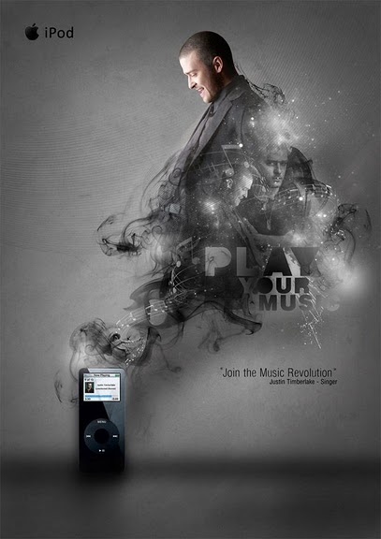

save water – tear – by rodrigozenteno
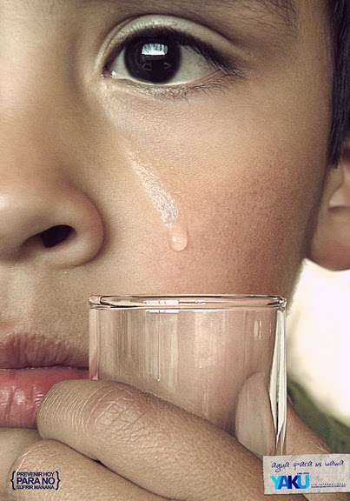

Nike Air Lab I – by he1z
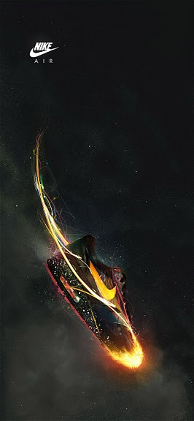

DIESEL Global Warming p.2 – by dr4oz
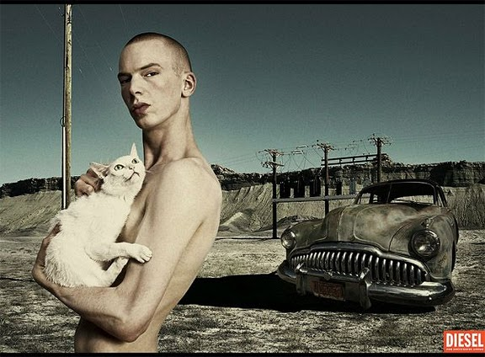

Tiger Vacuum Bottle: Camping
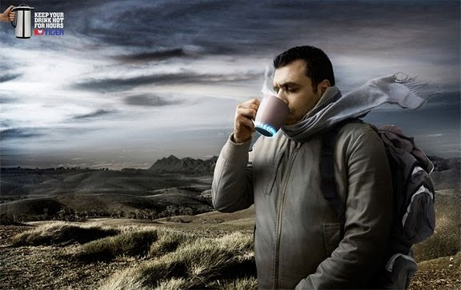

Martini Asti Elements – Fire – by he1z
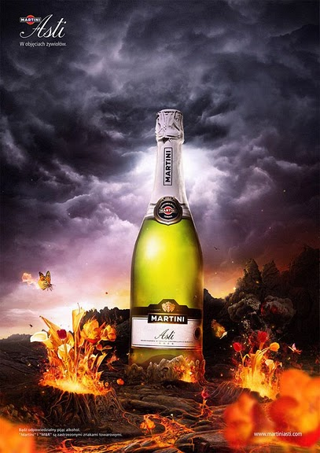

No Smoking – by waterist
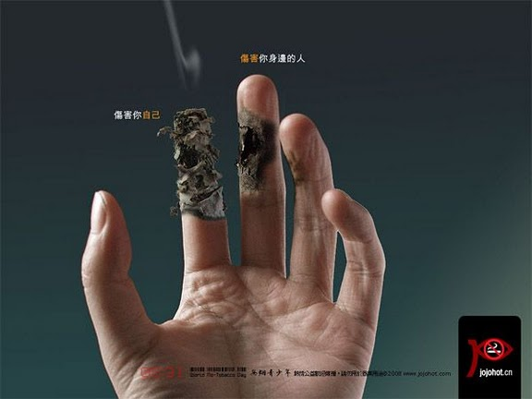

Nike – virtual project – by dr4oz
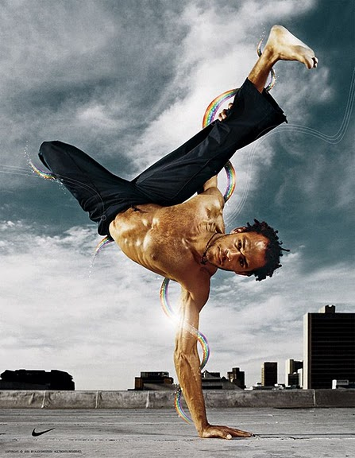

Majestic Media – Fire n Water – by pepey
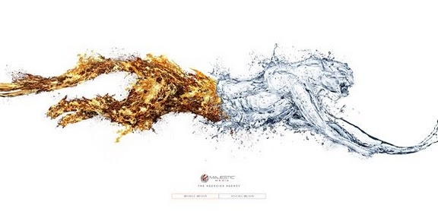

light – by tsdplus
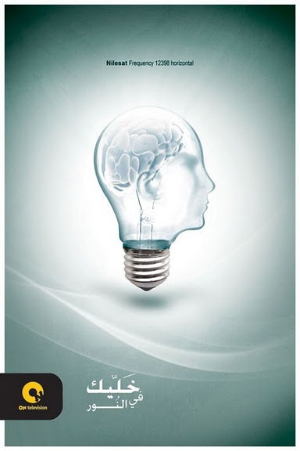

Mercedes4x4 – Final Ver – by m4gik
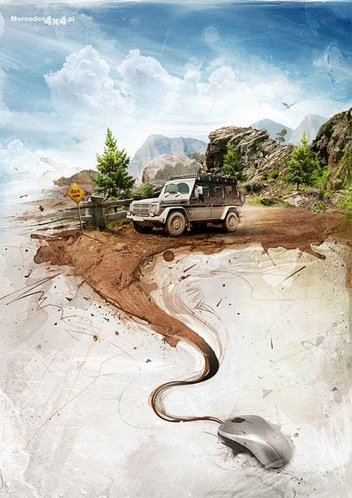

Ecology – by inSOLense
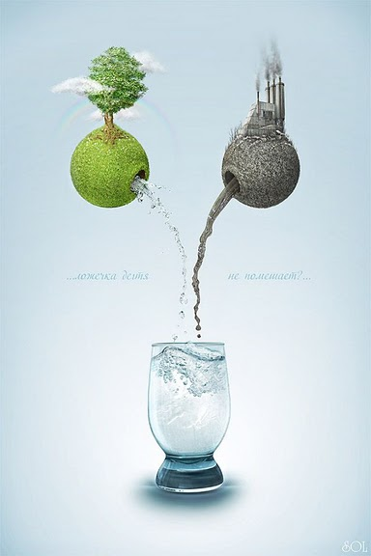

GREENPEACE – by Tanya Moseeva
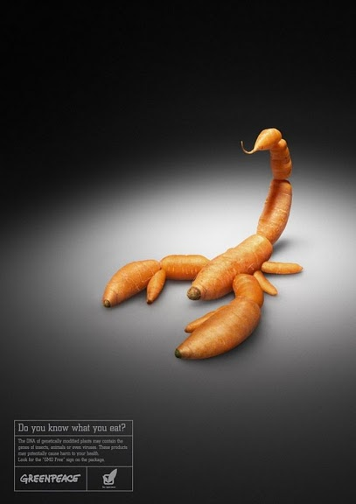

Production – by Dan Busta


HPB – by Soon Tong
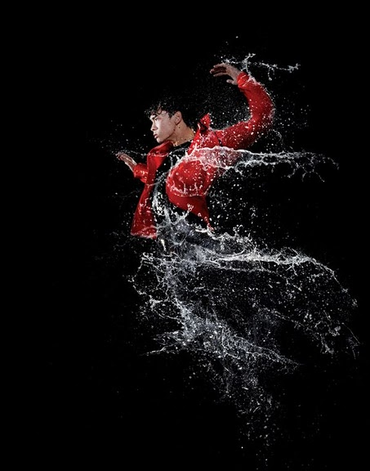

Let Imagination Take Over – by Driv
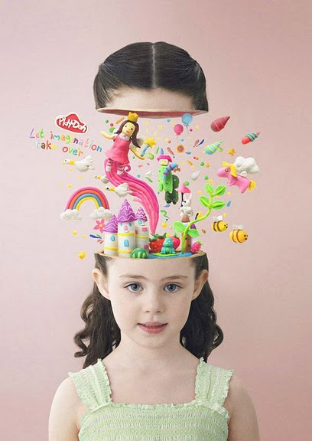

Eco Bottle Ad – by ishbu
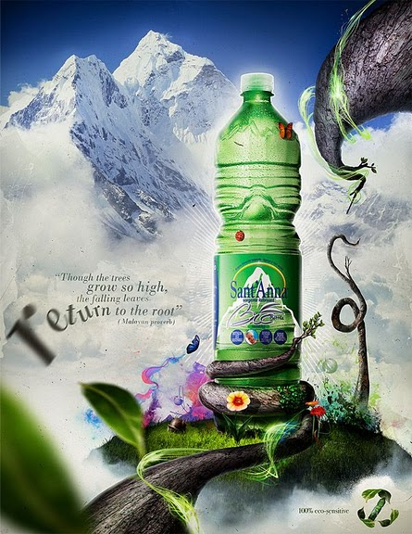

Etisalat info security – by 5835178


Heineken ads – by thekingpham
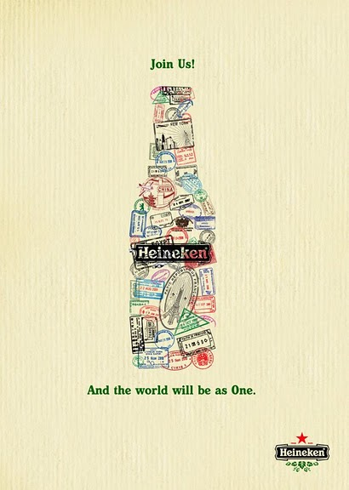

Ty Nant Water Advert
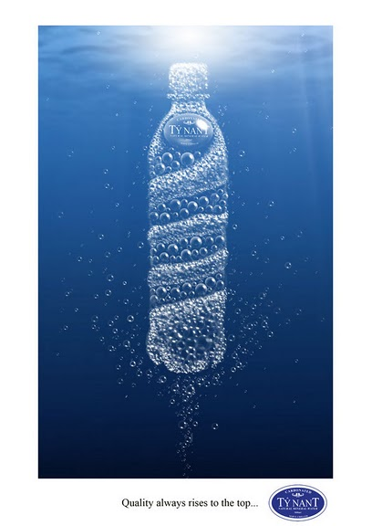

Breuninger “Metamorphosis”
