24 mẫu quảng cáo khó quên
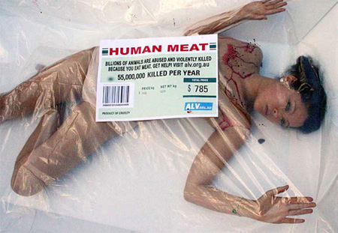
Why should ads be boring? Check out this collection of unforgettable advertisements from around the world.

Nissan Cube Advertisement
Break Glass in Case of Adventure. [link]
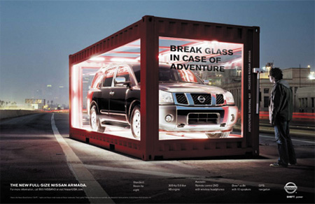

Nike Cars Advertisement
Cars decorated as Nike kicks in Mexico. The front car carrying the ball. [link]
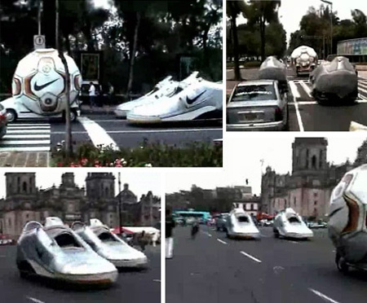

BMW Advertisement
“From up here, I can see BMW of Bridgeport” [link]
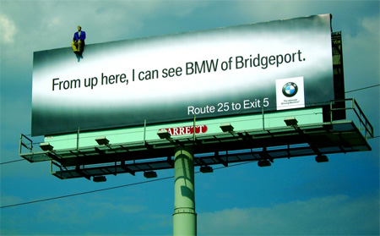

Nescafe Advertisement
This picture of a Nescafe branded building is from Venezuela’s capital, Caracas, and must be among the largest inflatables in the world. [link]
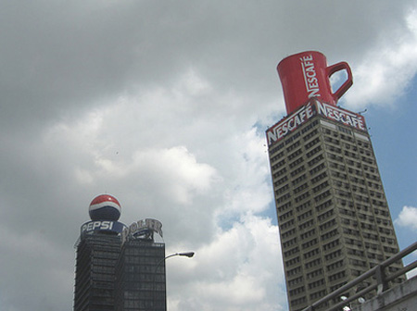

Nike Advertisement
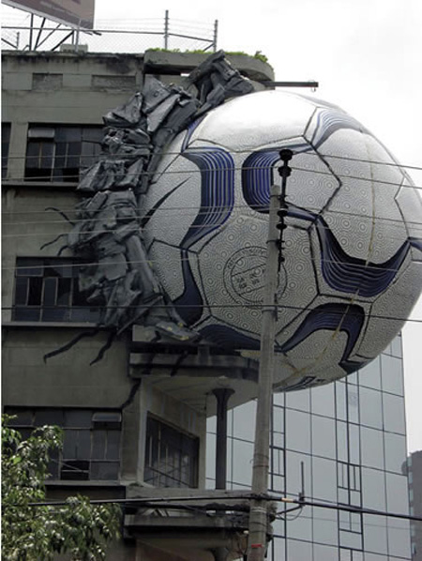

Nestle Advertisement
Creative Nestle billboard advertisement. [link]
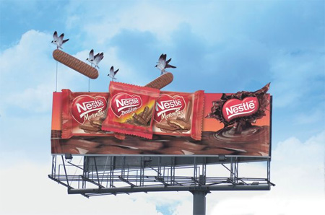

Mini Advertisement
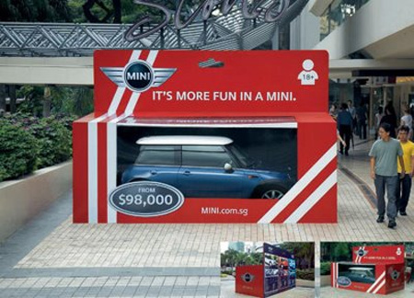

Hopi Hari Advertisement
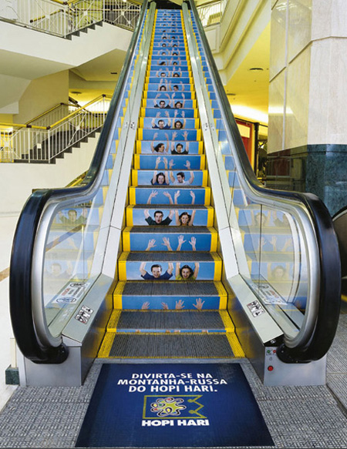

Fitness Company Advertisement
Shopping bags given away to customers when purchasing fitness accessories or nutritional supplements at the Fitness Company fitness centers. [link]
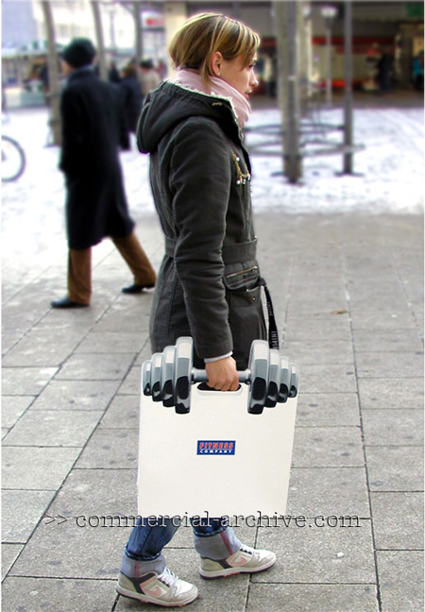

Skin Cancer Towel Advertisement
“Please take care this summer” [link]
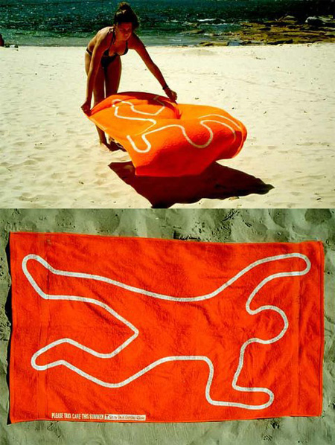

K-Swiss Advertisement
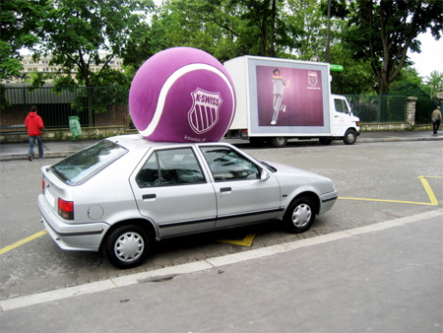

McDonald’s Bus Stop Advertisement
Just what you want while waiting for the bus: that mouth watering, tantalizing reminder of how much you’d love to stuff your face with a 1,000 calorie burger only to be reminded later by your stomach it wasn’t the best decision you could have made. [link]
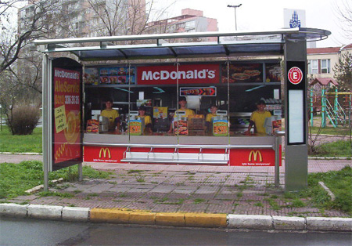

Woodland Shoes Advertisement
Powerful idea for a billboard. [link]
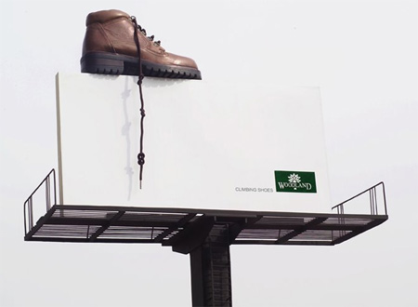

Outdoor Stunt by Goodyear
Lovely concept, but I think there’s something lost in translation in this outdoor campaign for Goodyear. The sign says:
(front) “Your vehicle has been towed. Call 0800 081-8181.”
(back) “For sticking on the roads.” [link]
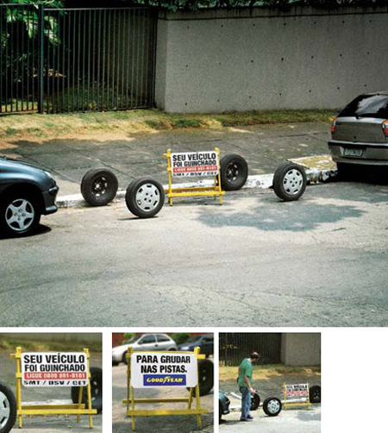

FedEx Kinko’s Advertisement
When coming up with an ad campaign for FedEx Kinko’s, the innovative minds at advertising agency BBDO were inspired by the streets of New York. The agency installed oversized bottles of correction fluid, highlighters, and, in one case, an office lamp, on the city’s busy thoroughfares for a couple of days earlier this year. [link]
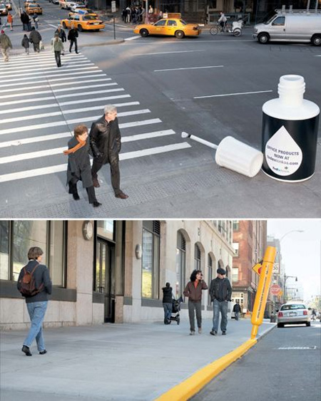

Peta Advertisement
The action is named ‘None of us would like to end up like this.. neither would other-than-human animals’ and it was done with four big foam trays, each of them containing a naked activist inside, and covered with a see-through plastic with a ‘Human meat’ sticker on it. The idea was to imitate the ‘meat’ trays we can find at the supermarkets and to show that we are also animals, just as other-than-human animals, we neither would like to end up there. [link]
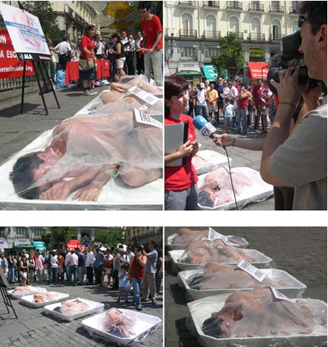

Ravensburger Puzzles Advertisement
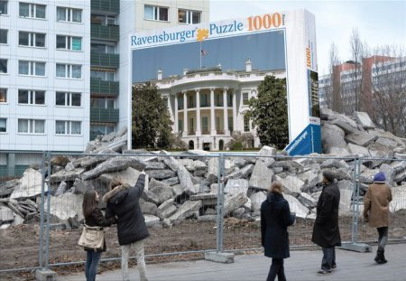

BIC Razor Advertisement
Bic developed this creative outdoor advertisement for their razors. The billboard is blank except for a small logo, but without it the advertisement might be missed and it acts as a good backdrop for the giant razor and cut grass. The only draw back is the constant trimming of the lawn. [link]
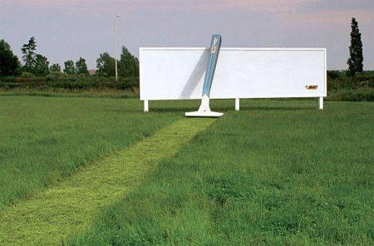

Mercedes Advertisement
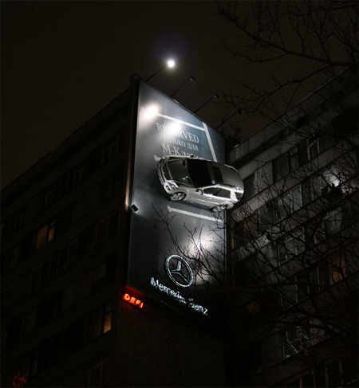

IKEA Advertisement
Ikea on Wheels advertisement. [link]
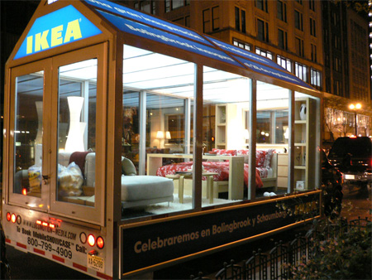

Canon Advertisement
Creative Canon outdoor advertisement. [link]
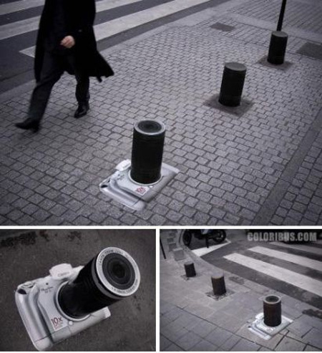

Kill Bill Advertisement
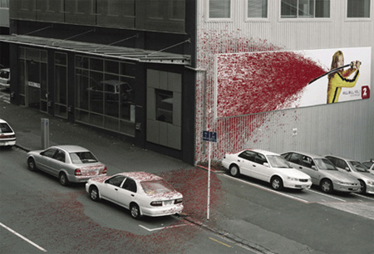

LEGO Advertisement
Lego’s ad agency in Santiago (Chile) used cranes to hang giant Lego blocks. [link]
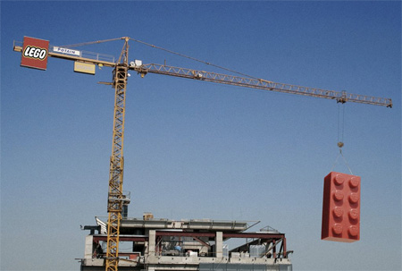

Discovery Channel Advertisement
