20 ý tưởng quảng cáo sáng tạo
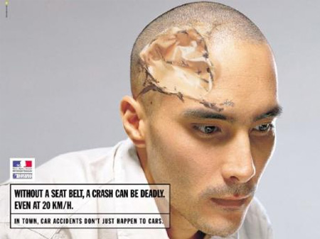
This post features 20 brilliant advertising ideas from around the world.

Pepsi Advertisement
Creative Pepsi “Straws” Advertisement [link]
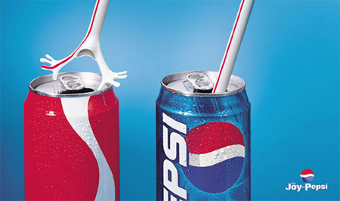

Playstation Bus Stop Advertisement
This bus station in Malaysia features boards with bubble wrap. [link]
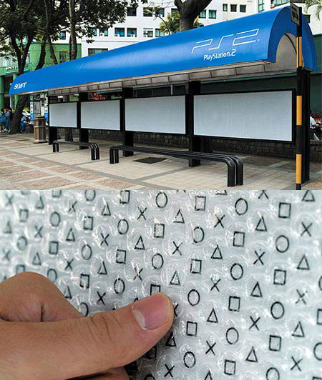

Dreamland Aqua Park Advertisement
Creative Dreamland Aqua Park “Wet Floor” advertisement. [link]
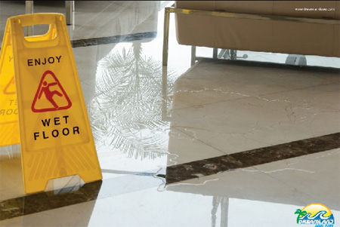

Bike Doctor Advertisement
Existing road icons were painted over with stencil. [link]
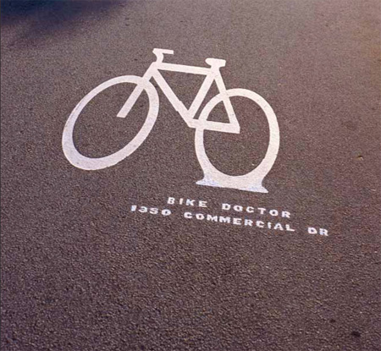

Sanyo Xacti Advertisement
Sanyo Xacti CA6 100% water proof digital movie cameras. [link]
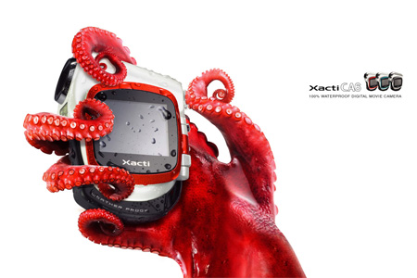

the Score Advertisement
The Score placed bricks in a tribute to Shaq O’Neal’s terrible free throw shooting. Hardcore sport fans know when a basketball player misses a shot, it’s called “throwing a brick”. The bricks were placed in front of popular sports bars and on basketball courts. [link]
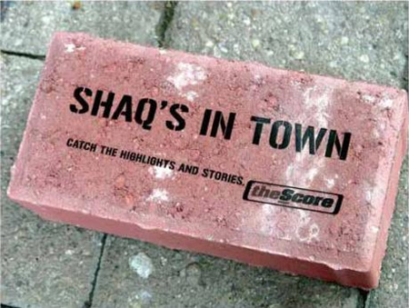

Smoke Is Poison Advertisement
12 meter long chemical tanker that looks like a giant cigarette was used by Cancer Research UK to highlight the toxic smoke in cigarettes. [link]
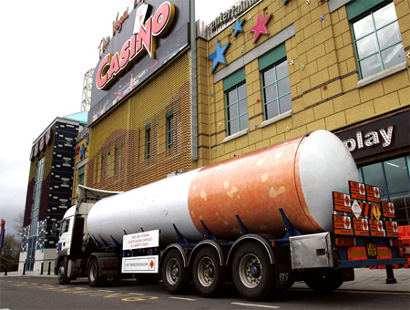

Pizza Hut Advertisement
Creative Pizza Hut “SWAT” print advertisement. [link]
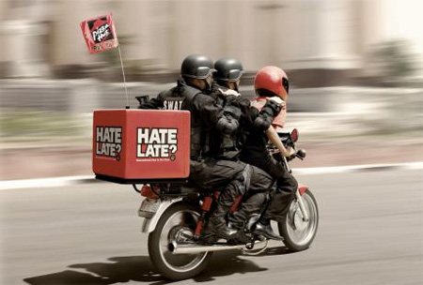

Nike Advertisement
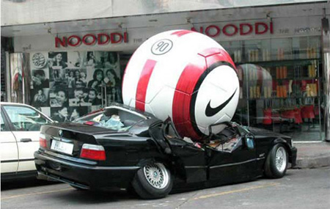

Eisenbahn Strong Beer Advertisement
Agency: CCZ Communications, Brazil. [link]
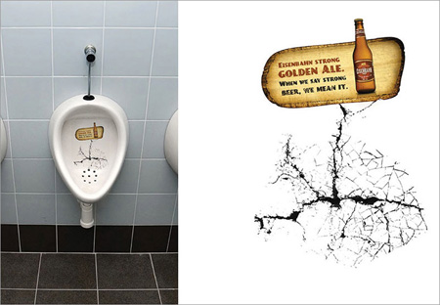

Bare Wetsuits Advertisement
“Stay down longer. Bare. Fit is everything.” [link]
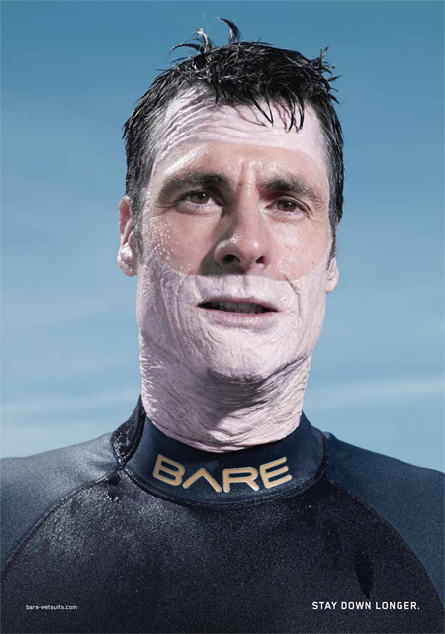

Just in One Bite Bus Advertisement
Creative ad using the side of a bus, that speaks for itself. [link]
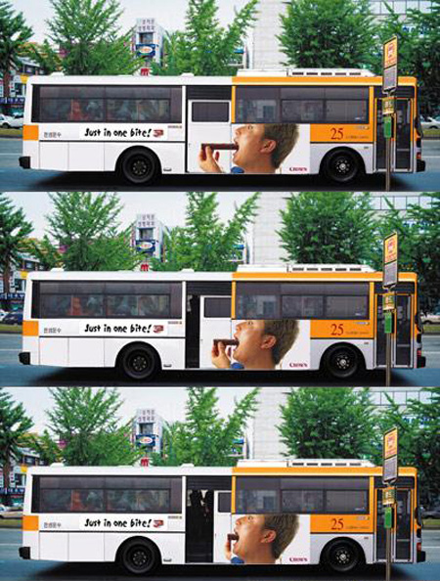

Gun-free South Africa Advertisement
“This is how easy it is to get hold of a gun in South Africa”. [link]
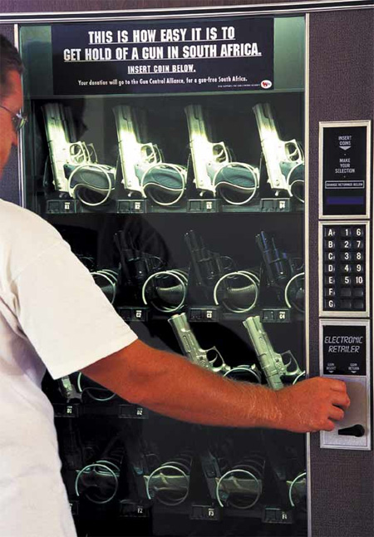

Heinz Ketchup Advertisement
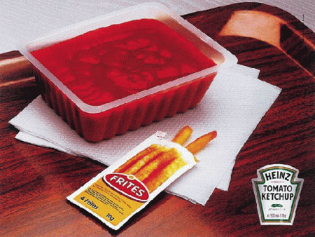

Visao Junior Advertisement
“It feeds the brain”. [link]
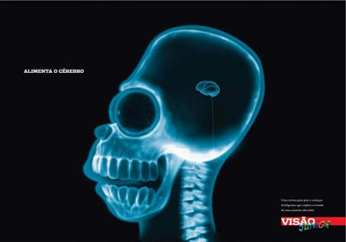

PSP Advertisement
PSP Billboard in SoHo. [link]
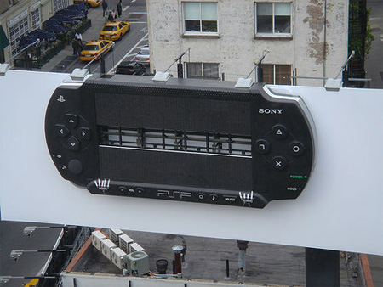


WMF Knives Advertisement
WMF knives: Cutting board. [link]
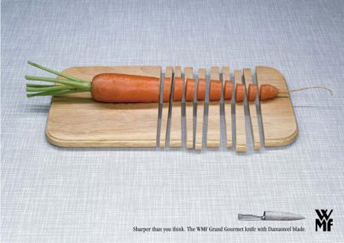

Drive Safe Advertisement
Always remember to drive safe! [link]
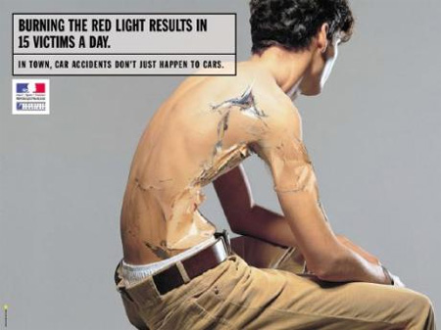

Perrier Advertisement
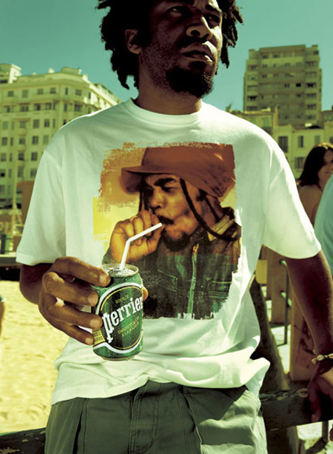

Matchbox Advertisement
Creative Matchbox “Parking” advertisement. [link]
